By NinoPrime

Here is a short tutorial on using ImgBurn to burn SNES MSU-1 games and MegaDrive/Genesis MD+ games to a CD. You can download ImgBurn free from here:
https://www.imgburn.com
ImgBurn supports all the Microsoft Windows OS's - Windows 95, Windows 98, Windows Me, Windows NT4, Windows 2000, Windows XP, Windows 2003, Windows Vista, Windows 2008, Windows 7, Windows 8 and Windows 10 (including all the 64-bit versions). If you use Wine, it should also run on Linux and other x86-based Unixes.
- Open ImgBurn and click on Write files/folders to disc.
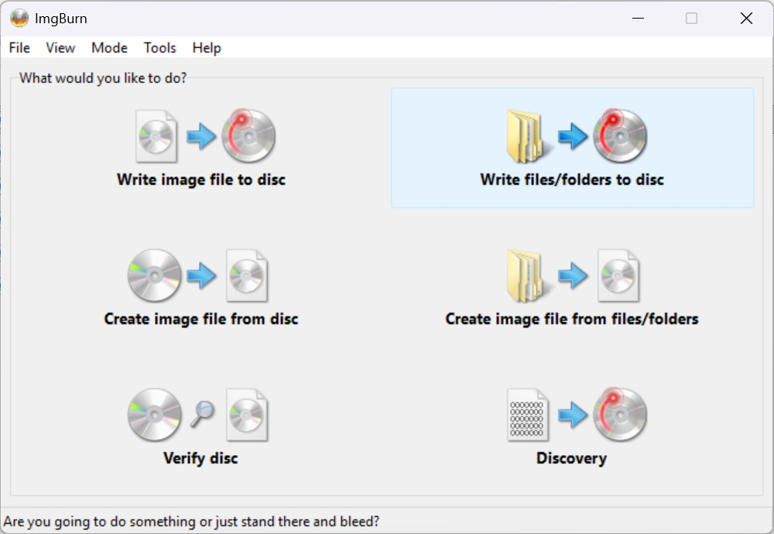
- Click on Browse for a file…

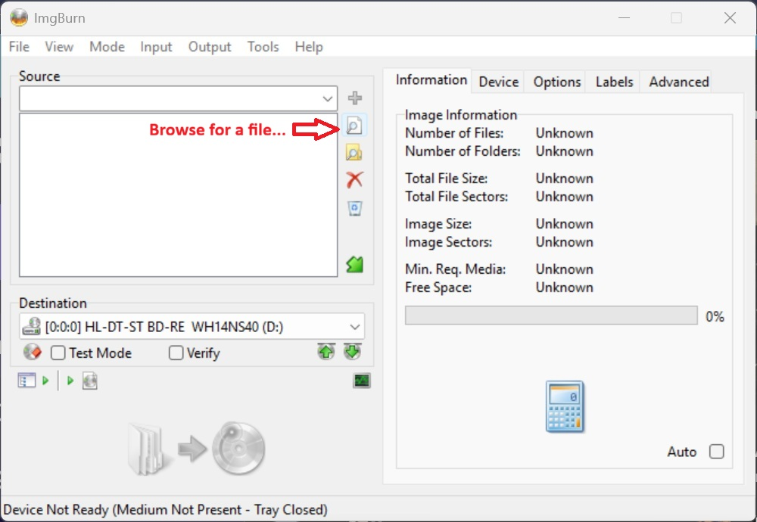
- The Windows file browser will open and you will then need to browse to where your game files are located. Game files must all be in one directory and not in subdirectories. For MSU-1 games, choose the all the files in .msu, .sfc and .pcm format. For MD+ games, choose all the files in .wav, .cue and .md format. Once they are all selected, click on Open.
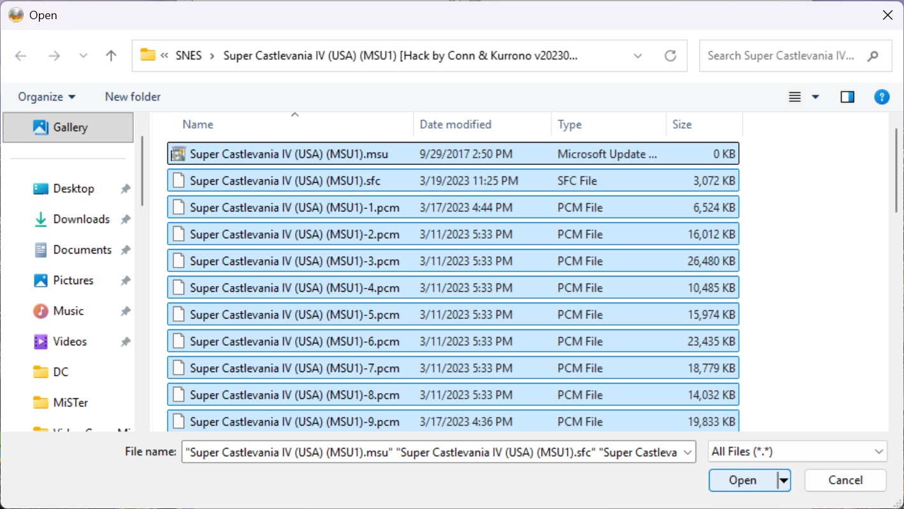
- Click on the Options tab and in the Image Options, Data Type needs to be set to MODE1/2048 and File System needs to be set to ISO9660 + Joliet
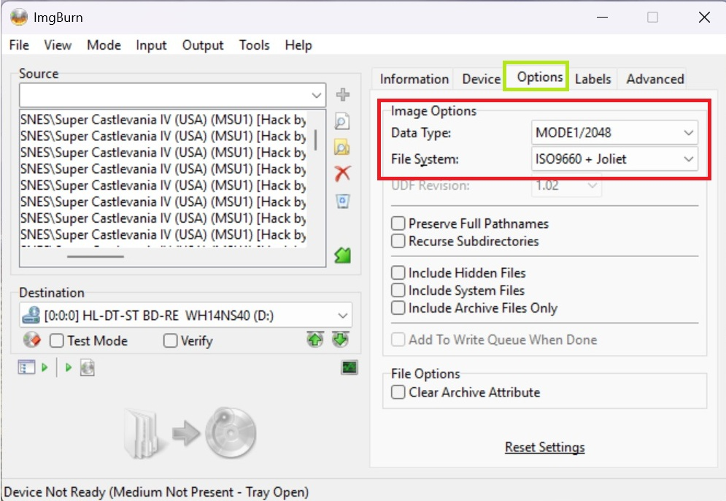
- *Optional* If you want to custom label your CD, click on the Labels tab and in the Volume Label section, type in the desired label in the ISO9660 and/or Joliet text field. If you want to change the Write Speed or how many Copies you want to burn, Go to the Device tab. Make sure your CD disc is inserted into your CD burner and that you can see your CD burner device listed in the Destination section (if you have more than one burner, you can choose the one you want to use in the drop down field).

Click the Ready button icon when you are ready to burn your CD.
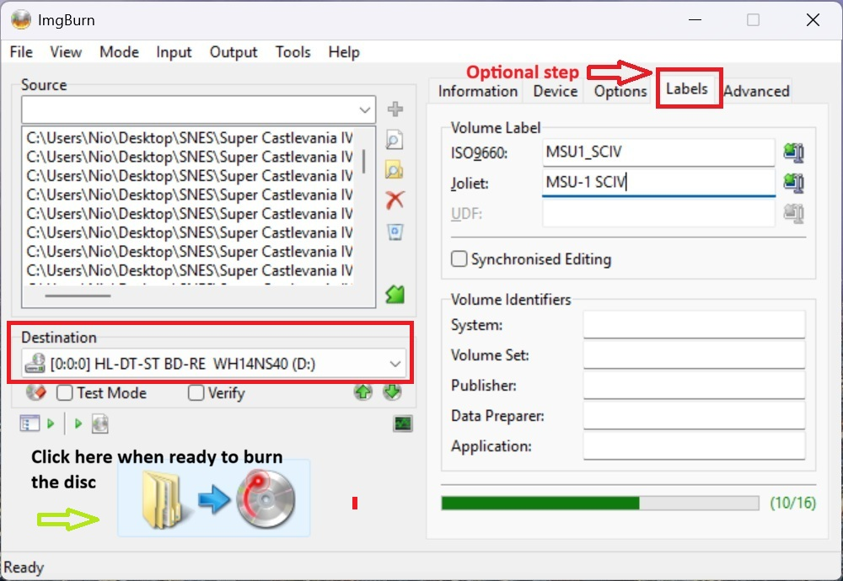
- A window will then open that will display a summary of what will be burned to the disk. Make sure you can see the amount of files that you chose in step #3, and that there are 0 folders listed. Once you are ready to burn, click on OK.
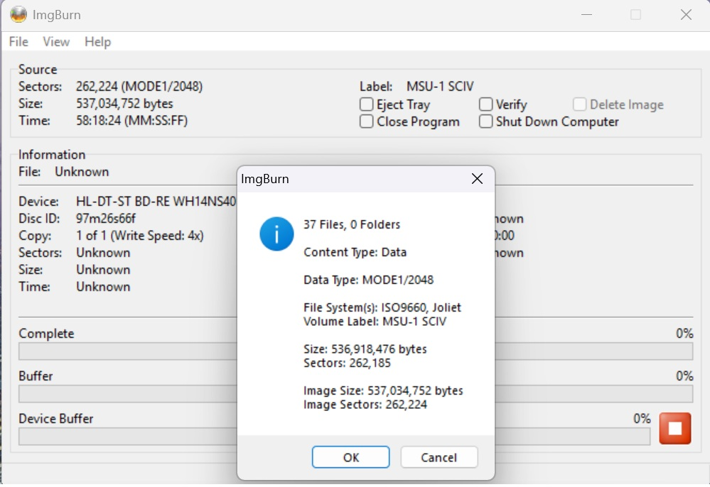
- Once the CD burning process has started, you will then see this screen that shows the percentage that the burning process is complete. This will depend on your burner’s CD burning capability as well as the speed of your CD media. You also have the option to tick the check boxes for Eject Tray, Close Program (when burning is completed), Verify (it will read the burned disc to verify the data burned onto it is correct) and Shut Down Computer (when burning is completed).
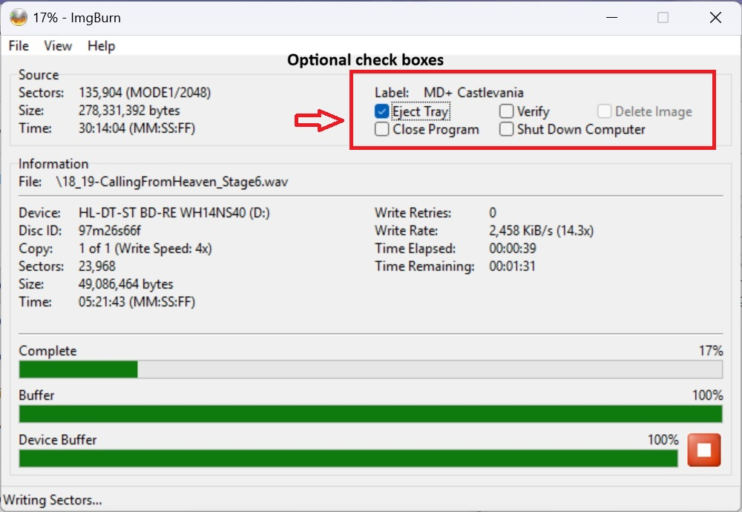
- Once the burning process has finished successfully. In this example, the burning process was successful and the Eject Tray option was enabled and the burner disc tray ejects the burned CD.
